1. **Face Detection using Opencv**

**Aim:**

To recognize face using opencv.

**Code:**

import cv2

image_path = r"C:\Users\prith\Documents\CV\cvimage3.jpg"

img = cv2.imread(image_path)

if img is None:

print("Error: Could not load the image. Check the file path.")

exit()

gray = cv2.cvtColor(img, cv2.COLOR_BGR2GRAY)

haar_cascade_path = cv2.data.haarcascades + "haarcascade_frontalface_default.xml"

face_cascade = cv2.CascadeClassifier(haar_cascade_path)

if face_cascade.empty():

print("Error: Could not load the Haar Cascade file.")

exit()

faces = face_cascade.detectMultiScale(gray, scaleFactor=1.1, minNeighbors=5)

for (x, y, w, h) in faces:

cv2.rectangle(img, (x, y), (x + w, y + h), (0, 255, 0), 2)

cv2.imshow('Faces Detected', img)

cv2.waitKey(0)

cv2.destroyAllWindows()

**Input:**



**Output:**

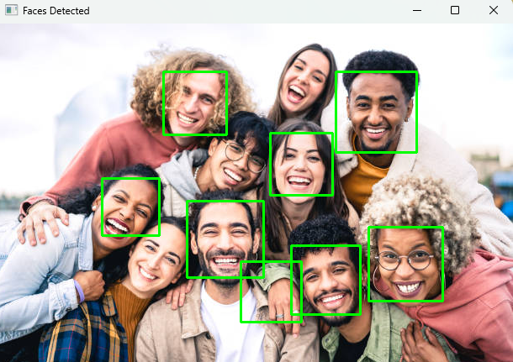

**Result:**

The python code to recognize face using opencv has been executed successfully.